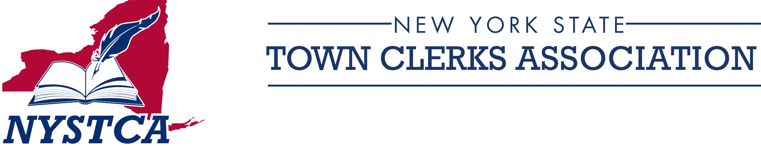
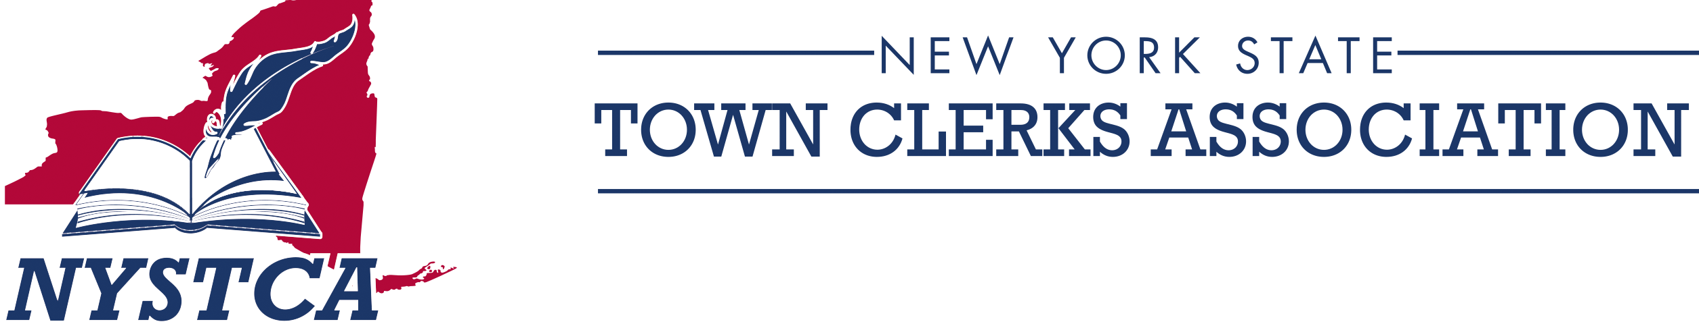

FIRST VICE PRESIDENT
Marie L. Little, RMC, MMC

SECOND VICE PRESIDENT
Tamera Vezzose, RMC

THIRD VICE PRESIDENT
Allison Vento, RMC, MMC

SECRETARY
Karen M. Sweeting, RMC, CMC

TREASURER
Tracy Villnave, RMC

EX-OFFICIO
Susan Haag, RMC, MMC

DISTRICT DIRECTORS
#1 Andrew Raia
Denis Noncarrow
#2 Patricia Kalba
Becki Tompkins
#3 Julie Gansle
Sheila Paul
#4 Susan Baldwin
Brenda Howe
#5 Cortney Rhinehardt
Angela Epolito
#6 Karen Miller Kenerson
Tom Peer
#7 Carol Chase
Eve Fisher
#8 Hannah Hill
Nicole Begin
#9 Heidi Smith
Kathryn Kalluche
#10 Gretchen Hind
Amy Bellardo

Dear Town Clerk:

It is time to renew your NYSTCA membership!

Your annual membership beginning July 1, 2023, is only $85.00.

Benefits include:

- Deputy(s) membership at no additional charge.
- The quarterly newsletter - ‘Recorder’.
- Reduced registration for Annual Conference and Regional Meeting(s).
- Access to our private Facebook page
- Access to the Members Only page of the NYSTCA website.
- Educational webinars.

You can process your annual membership application and payment at www.nystca.com or complete the enclosed application and mail with payment via USPS. We value having the most current information. Kindly take the time to answer the questions on the application, there have been some minor changes and the information you provide is important to us.

Mail your payment, payable to NYSTCA, and application to:

Karen M. Sweeting
Town of Sweden
18 State Street
Brockport, NY 14420

As always, thank you for your continued support and involvement in “your” association.

Kind Regards,
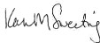
NYSTCA Membership Chair Enc. Application & Voucher

PS Mark your calendars, the NYSTCA 2024 Conference will be held in Albany, April 21 - 24, 2024.

Town of Dryden
93 East Main Street
Dryden, New York 13053
Phone: 607-844-8888, Ext. 210
Email: townclerk@dryden.ny.us
www.nystca.com

Bambi Avery, RMC, MMC
President

